Athletic Officials Checklist

☐ Evidence of Terms of Agreement
- Must clearly state how much they will get paid for their services (prior to supplying the services), if not currently listed on Athletic Official Fee Schedule (housed by Purchasing & Accounts Payable)
  - Email is acceptable

☐ W-9
- Payee is required to submit their W-9, as this is a taxable service

☐ Standard Voucher
- Areas to complete on Standard Voucher:

Top portion – Payee Information
- Payee Name (first & last)
- Email Address
- Address (Street, City, State Zip)
        - (where the check will be mailed to)

Middle Section – Description of Material/Service
- Date(s) and goods/services provided
- Total
- Net = Grand Total to be paid

Payee Certification
- Payee signs (no e-signature allowed)
- Date

Supervisor’s Certification
- Dept Chair signs (no e-signature allowed)
- Title
- Date

Cost Center Unit
- Add account # to charge
- Receipts & Backup
  - ☐ Scan voucher & backup and combine into (1) PDF with Standard Voucher.
    - ☐ Email fully signed Standard Voucher and backup to accounts.payable@cortland.edu.
Standard Voucher cannot be digitally or e-signed.

Signature Types:
NOT Allowed:
- Typed signature:
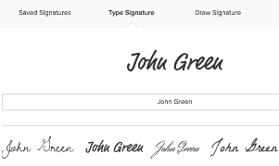
- Digital Signature:
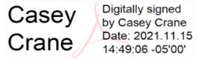
ALLOWED (original signature scanned):
- Original, scanned
